Lab 2

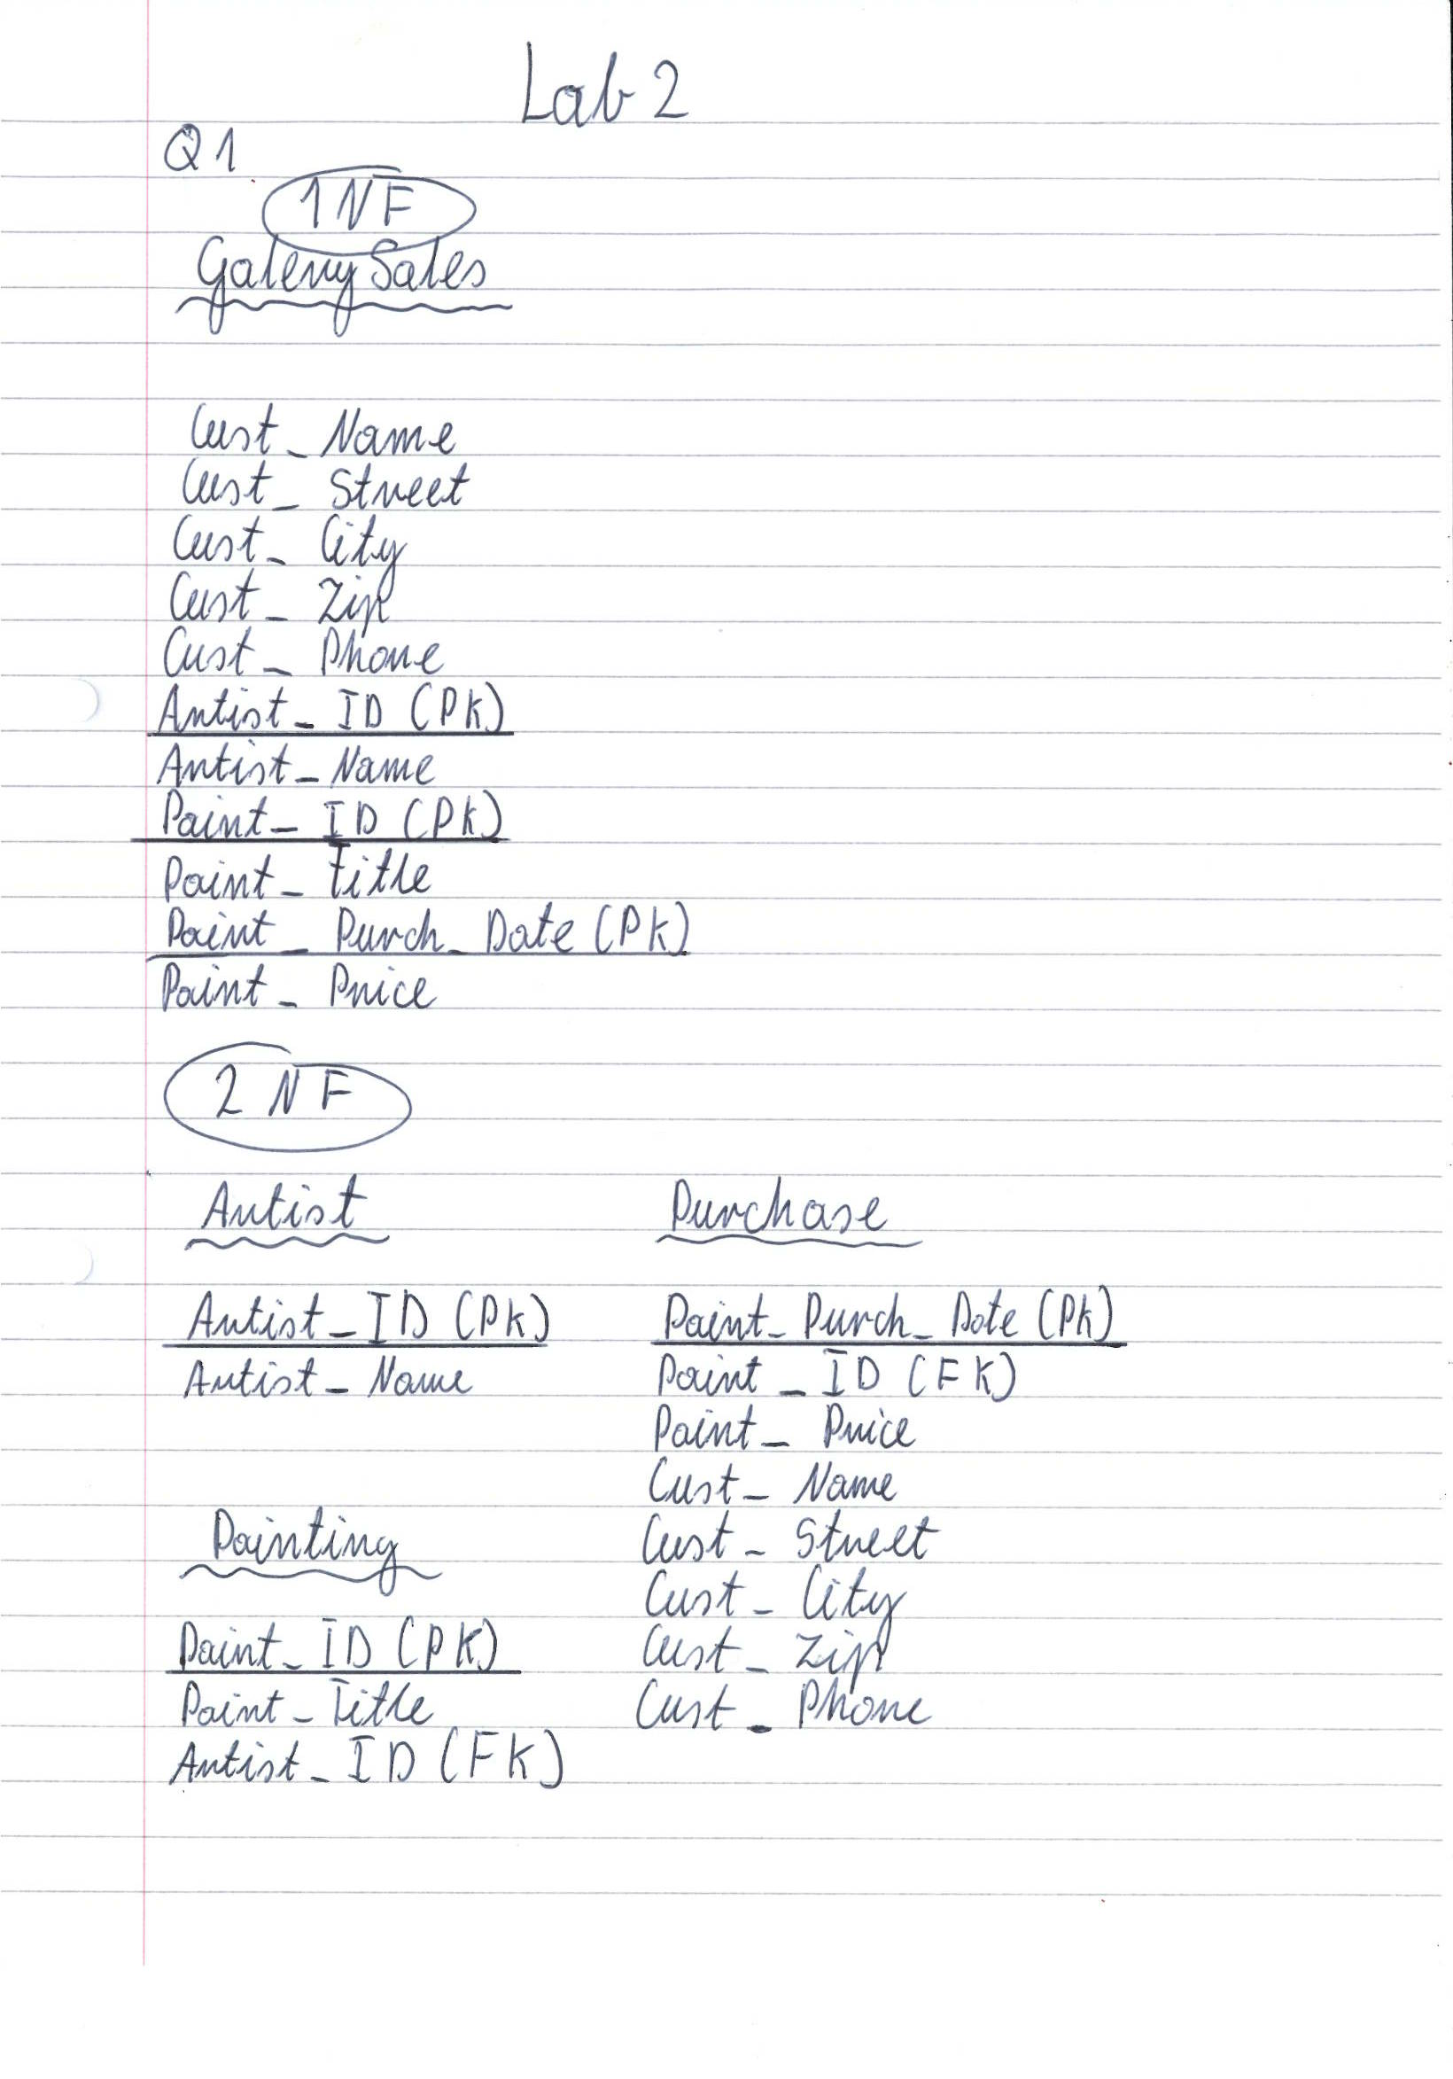

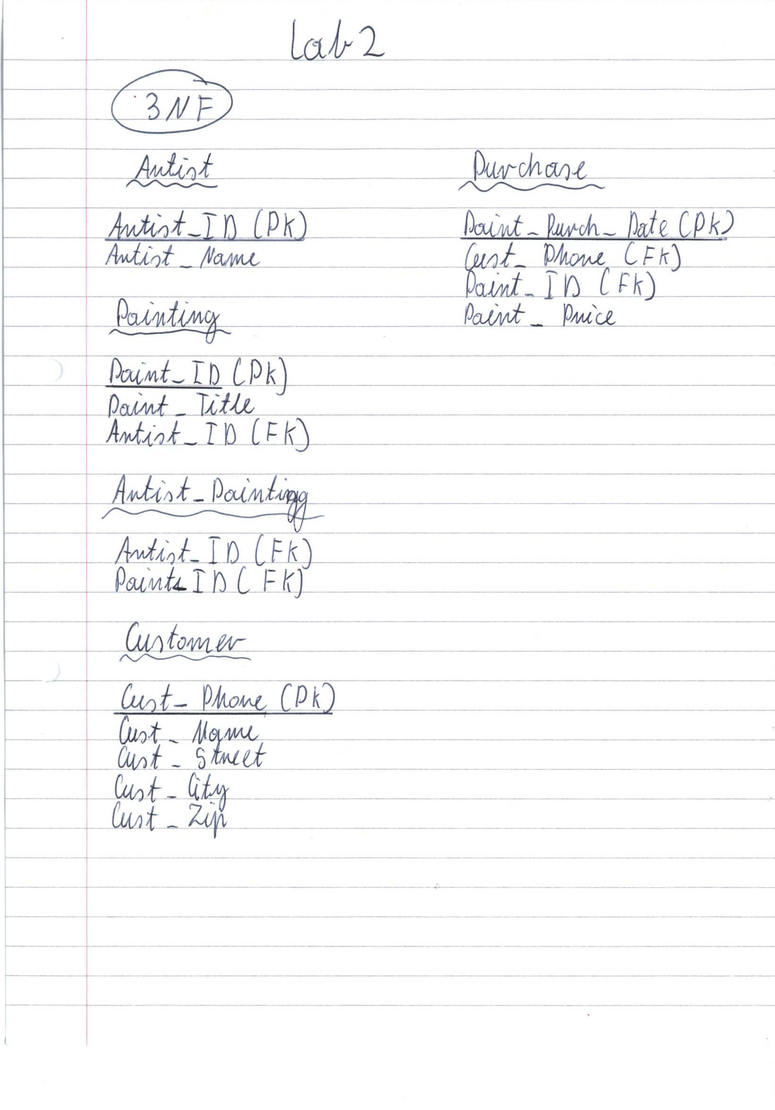

**Q2**

*Apps_NOT_Normalized*

**Application-No**

**StudentID**

StudentName

Street

State

Zip-Code

ApplicYear

Reference-Name

RefInstitution

Reference-Statement

**PriorSchool-Id**

Prior-School-Addr

GPA

----------------------------------------------------------

*APPLICATION*

**Application-No (PK)**

**ApplicYear(PK)**

StudentID(FK)(PK)

*STUDENT*

**StudentID(PK)**

StudentName

*ADDRESS*

**Street(PK)**

StudentID(FK)(PK)

State

Zip-Code

*PIORSCHOOL*

**PriorSchool-Id(PK)**

StudentID(FK)(PK)

Prior-School-Addr

GPA

*REFERENCE*

**Reference-Statement(PK)**

StudentID(FK)(PK)

Reference-Name

RefInstitution

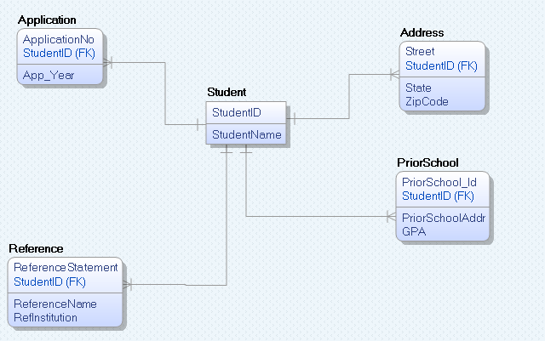

**4. The normalized tables are usually more storage-efficient. What is the gain in storage efficiency (=the size in bytes of the normalized tables divided by the size of the starting non normalized table)?**

Apps_NOT_Normalized = 1007 bytes

Application = 12 bytes 0.01

Student = 54 bytes 0.05

Reference = 704 bytes 0.69

PiorSchool = 112 bytes 0.11

Address = 141 bytes 0.14

Overall = 1023 bytes 1.01